Link each picture with its name !
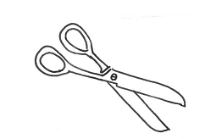 A rubber
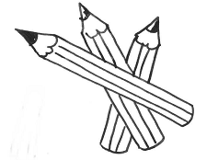 Scissors
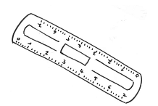 A schoolbag
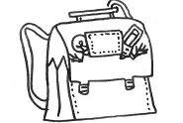 A pen
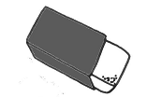 A ruler
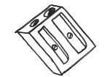 A pencil sharpener
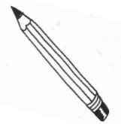 Colour pencils
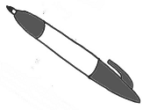 A pen
 |  | 2
1 | A
 |  |  | B
 |  |  |  | 5
 |  |  |  |  |  | C
 |  |  |  |  |  |  |  |  |  |  |  | 3
 |  |  |  |  |  |  | 4
D

1 | 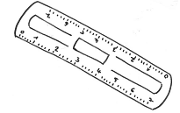 | A | 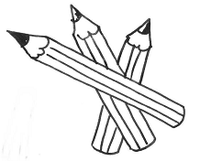
2 | 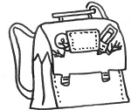 | B | 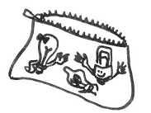
3 | 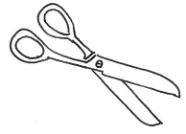 | C | 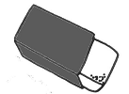
4 | 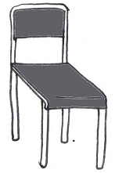 | D | 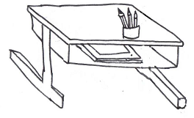
5 | 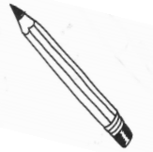
Complète les phrases :

She has got …………………………………. He has got a…………………………………

I have ……………………………………………………………………………………………………………………………..

Formule des phrases pour dire le matériel scolaire qu’ils possèdent :

……………………………………………………………… ………………………………………………………………… ………………………………………………………………… ………………………………………………………………… …………………………………………………………………… ………………………………………………………………
Et toi qu’as-tu dans ta trousse ?
………………………………………………………………………………………………………………………………………………………………………………………………………………………………………………………………………………………………………………………………………………………………………………………………………………………………………………………

